Week 6 – Workflow / Session State Model
Code: src/state.py (SessionState, Phase, TRANSITIONS) · Used by: src/bounded_agent.py
Tests: tests/test_week6.py::StateModelTests

Why an explicit state model
In Week 5 the run state was a loose dict with three keys. It could not say where in the workflow a run was, and nothing prevented illegal jumps. Week 6 turns the workflow into a small state machine: one named phase at a time, only documented transitions allowed, every transition recorded for the trace.

Phases
Phase | Meaning | Terminal?
intake | Student message received; nothing verified yet | No
case_verified | get_case_status succeeded and the student owns the case | No
case_not_found | Lookup failed, or case belongs to someone else (same message for both) | No
awaiting_confirmation | Memory raised a duplicate-ticket warning; student must decide | No
ticket_created | Simulated ticket created | No
responded | Final answer given | Yes
limit_reached | MAX_ITERATIONS (3) hit | Yes
failed | Unrecoverable problem (e.g. multiple simultaneous tool calls) | Yes
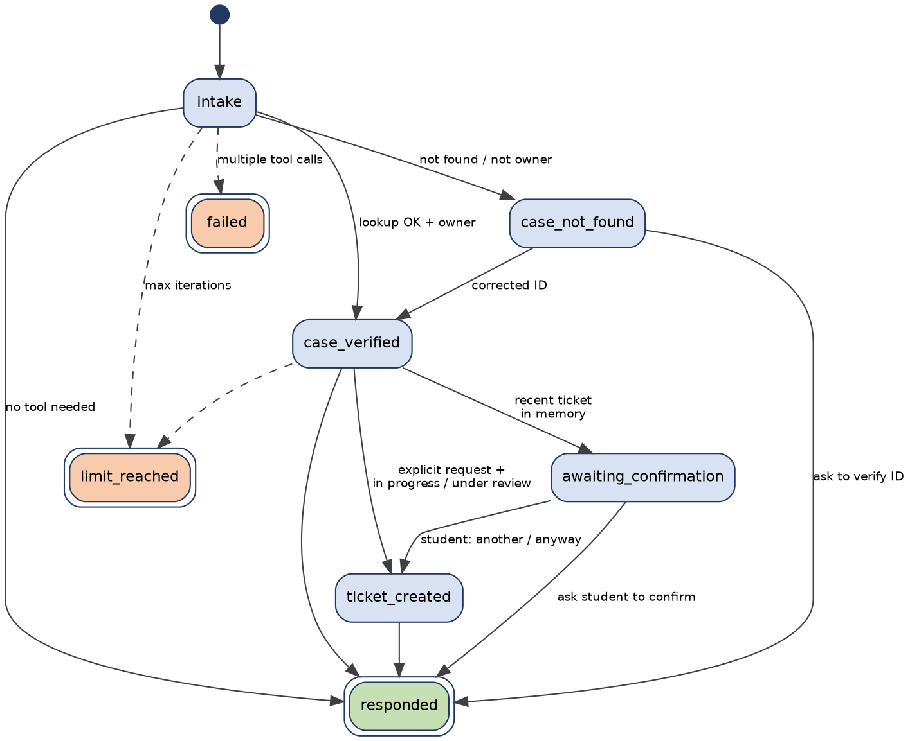
Workflow state diagram

What lives in session state (and what does not)
Field | Purpose | Persisted after the run?
session_id | Correlate trace entries | No
student_id | Set by the application after authentication, never by the model | No (traces show only a hash, student_ref)
memory_enabled | True only if the student has consented | No (consent itself is stored in memory.py)
phase, iteration, transitions | Workflow position and history | Trace only
checked_case_id, case_result | Authorise a ticket only for the case just verified (Week 5 rule) | No
ticket_created, ticket_id | One ticket per run | No
memory_events | Every memory read/write/skip in this run | Trace only
Session state vs. memory. Session state dies with the run. Anything that must survive goes through memory.py, which has consent, retention and deletion rules (see the Memory Design Note).

Guarantees and where they are tested
- A ticket cannot be reached straight from intake (must pass case_verified) – test_cannot_create_ticket_straight_from_intake
- Terminal phases are final – test_terminal_state_is_final
- Traces never contain the raw student ID – test_snapshot_hides_raw_student_id
- Week 5 rules still hold via the dict-style compatibility layer – the 14 Week 5 tests pass unchanged

